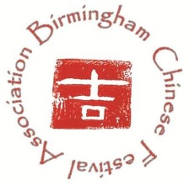
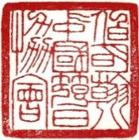

2019 Birmingham Chinese New Year Festival Gala

Performance Registration Form

Times are changing and new traditions arise, but what doesn’t change is the meaning and impact of Chinese New Year. Birmingham Chinese New Year Festival Association (BCFA) invites you to celebrate the Year of the Pig by registering for performances of individuals and groups for the 2019 Gala. Come be part of celebration to welcome in the Year of the Pig and help us to make 2019 Chinese New Year Gala a memorable occasion in Birmingham!
Register Now!
- The 2019 Birmingham Chinese New Year Festival will be held on Saturday, February 2, 2019 from 11 AM to 2:30 PM at Boutwell Auditorium with a dress rehearsal the evening of Friday, February 1, 2019.
- The focus of the performances should reflect traditional or contemporary Chinese culture/arts.
- Please complete the following registration form and email to bcfabirmingham@gmail.com by Sunday, November 18, 2018.
- Deadline to submit the BGM (background music, mp3/mp4 format file) and dress rehearsal video link is Sunday, December 16, 2018.
- Only one person is required to register for each group.
- Please fill out a separate form for each performance.
- The volunteer performers will receive free admission and free lunch.
- All applications will be reviewed by BCFA Entertainment Committee, and decisions will be emailed by the end of December based on the rehearsal video provided by each group.
- The Entertainment Committee will reserve the right to adjust performances depending on other conflicts.
- Contact:
- Mr. Jianzhong Liu bcfabirmingham@gmail.com
- Mrs. Bing Wang bcfabirmingham@gmail.com
Performance Registration Form
Individual/Group Name
English: _____________________________
Chinese:
Individual/Primary Contact’s Info
Name:
E-mail:
Phone:
Performance Title
English: _____________________________
Chinese: ____________________________
Style Singing( ) Dance( ) Musical Instrument( ) Kong Fu( ) Other:_______
Number of Performers _______
Names of Performers (in English) __________________ __
__ _
__ _
__ _
Length of the Performance (less than 6 minutes) ____________
Music Accompanist: Yes( ) No( )
Description of Performance:
English: _________________________________________________ _______

Chinese: _________________________________________________ _______

